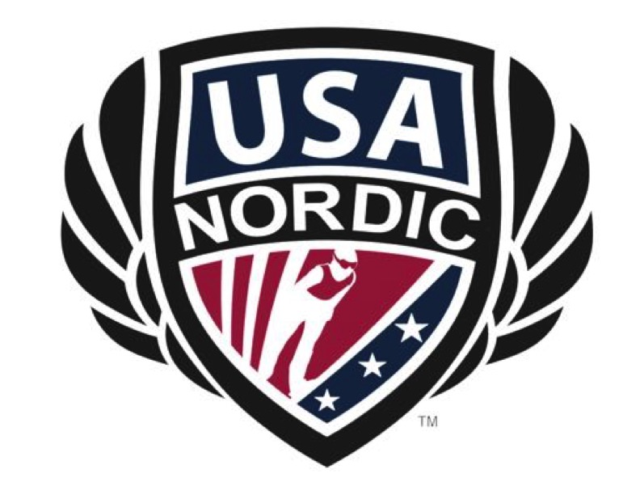
USA Nordic Sport
Summit Committee Report
Date 4/24/19

Membership Committee
Chair of Committee: Jed Hinkley
Committee Members:

- Jim Holland
- Jeff Hastings
- Tom Bickner
- Kathleen Doyle
- Tami Jastrow
- Zach Jastrow
- Karen Compten
- Dick Ziegler
- Jennifer Hassrick
- Cristi Clccio-Kloc
- Todd Wilson
- Calvin Scharffs
- Melody Schreiner
- Gary Summerton
- Stacey Border
- Alana Maki-Foust
- Andy David
- Scott Halvorson
- Rich Zuckerman
- Mike Gibson
- Scooter Maloney
- Cindy Schini
- Cheryl Tourville

Committee Priorities FY ‘18-19:
- Grow membership
- Improve communication between USANS and clubs
- Recognize athletes for accomplishments
- Create resources for the community
- Come up with ideas on how to best promote and grow the sport
- Re-implement club scorecard
- Gather Club date

Major Accomplishments FY ’17-18:
- New registration/renewal format
  - Increased total membership by 25%
    - 418 to 523
  - Increased athlete membership by 32%
    - 233 to 307
  - Increased coach membership by 293%
    - 16 to 47
  - Increased official membership by 362%
    - 8 to 29
- Paid athlete membership
  - Brought in $4020
  - 73% of the athlete memberships were paid
- Parent Resources
  - Ski Jumping Safety
  - Ski Jumping 101
  - Ski Jumping Glossary
  - Organization explanation
  - History of Ski Jumping
  - Ski Jumping equipment
  - Ski Length and binding placement rules
  - Information tri-fold
- Parent contacts at clubs
- Map of Clubs in the United States
- New format for US Cup Junior Series
- Virtual Championships with Norway

Action Items In Progress/Pending FY ’17-18:
- Club Membership
- Grow membership further
- Implement new membership cycle
  - July 1 to June 30
- Continue to create resources
  - Parent Safety check
  - Guidelines for holding a competition
  - Best Practices

Committee Strategic Planning Action Items to address FY ’18-19 (LIST ALL that Committee COULD address):
- Retention of athletes
- US Junior Cup Series format and process
- How to grow Virtual Nationals and Virtual Worlds
- How to add value to the USANS Membership
- Requirement for all athletes to be USANS members if they want to compete
- Best practices for clubs to sign athletes up
- Best Practices for club activities
  - From Sport Development Plan
  - Pertains to things like hill progression, recruitment, retention, making jumping fun, and more
- Club insurance

Items for Collaboration with other Committees:
- Work with Comp committee on athlete retention
- Work with fundraising committee on national fundraisers
- Work with/establish a communications sub-committee

Steps needed to be addressed for May 2018 Summit Meetings
- Share club numbers by region and club
- Establish process for rolling out 2018/19 Membership
- Decide on requirements for different levels of competitions
  - Springer
  - US Cup Junior Series
  - Junior National Qualifiers
Budget concerns based on Action Items for FY ’17-18 (Financial resources required/requested):
- Not much except printing materials

Submitted by: _______Jed Hinkley______________ Date: _____4/16/18_______

